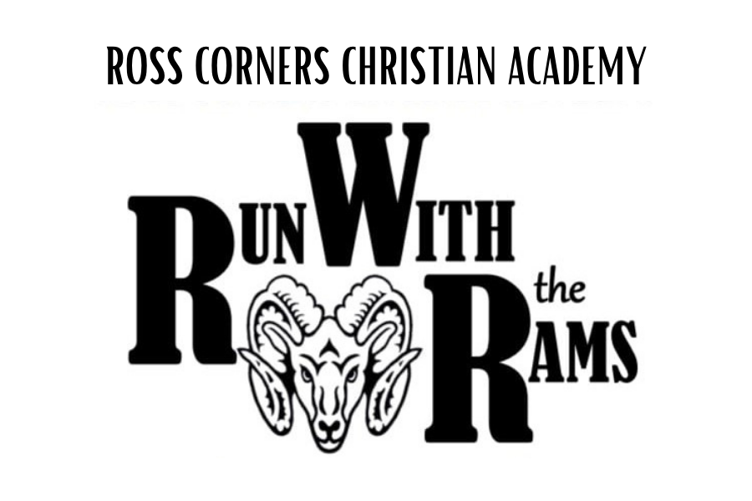
RWR 2026 “Run With The Rams”
What is Run With The Rams?
Run With The Rams (“RWR 2026”) is our largest annual fundraiser and funds our scholarship program. Many of you have benefited from this fund each year with scholarships, pastoral and multi-child discounts, and we believe that you will want to participate and pass the blessing on to many more families who need financial assistance. As always, we count on every family’s participation in order to make this a success. ALL families who received a discount or scholarship in the 2025-2026 school year and plan to apply for financial assistance in 2026-2027 are REQUIRED to participate in this fundraiser. Failure to participate will result in declining financial assistance (scholarships, pastoral and multi-child discounts). Due to the fact that this is our only means of raising scholarship funds, families who utilize this program are required to participate.

What Do The Students Do?
We are asking each RCCA family to raise at least $650 by getting sponsors to support your student/s as they walk/run laps around our soccer field for 30 minutes. The “run” will take place on Thursday, May 21st.

What Do I Need To Do As A Parent?
- Register each of your students online.
You can do this on the “RWR 2026” link under the “events” tab on our website rccarams.org .
This will bring you the RWR 2026 race website.
-Under “Events” you will choose “RCCA STUDENT ONLY Sponsor Run Around Soccer Field”.
-Click the blue “Sign Up” button. This is very important as it will be a way for your student to raise their funds online and where you will enter your child’s T-shirt size for their free T-shirt.
*This will also enable you to generate your student’s personal sponsor link that you will be able to share with your family & friends via e-mail or on your social media sites.

**If you are struggling with this step, call Mrs. Michaela Wyse at 607-748-3301 or email rcca.office@rccarams.org and she will set that up for you. This step must be completed for each student on or BEFORE APRIL 15th.

- Choose 15-20 family members or friends who you believe would be willing to help support RCCA.
-Write their names and addresses on the envelopes provided.
-Place stamps on each letter.
-Turn in the stamped, addressed letters into the school office by Wednesday, April 15th.
**Do not mail the letters yourself. **
They need to be mailed from the school office in order to be credited to you.
Please make sure all addresses are properly filled in and that each letter is signed by your student or family.

3. Fill out the Recipient List (Blue sheet sent in each folder).
This step is extremely important so that RCCA can make sure the students will receive proper credit as donations
come in. Turn in this list along with your stamped, addressed envelopes.

*Once your completed family packet is returned to the RCCA office, each of your students will be counted to receive a Free RWR 2026 T-shirt! (Please return all items in the large, yellow envelope that was provided by April 15th)

How Else Can I Participate?
RCCA Family- Join your student for RWR 2026! Register on our website under the events tab on our website! Family members registered by Monday, May 4th will receive a RWR 2026 T-Shirt!

*see back*

RWR 2026 PRIZES
(Must raise a minimum of $650)

Family Prizes:

- 1st Place: $500 off total family tuition for the 2026-2027 School Year and a Family Fun Gift Basket (Not Redeemable for Cash)

- 2nd Place: $250 off total family tuition for the 2026-2027 School Year and a Family Fun Gift Basket (Not Redeemable for Cash)

- 3rd Place: $100 off total family tuition for the 2026-2027 School Year and a Family Fun Gift Basket (Not Redeemable for Cash)

- 4^{th-} 10th Place: Family Fun Gift Basket

Staff Prizes:
The top teacher/staff member Fundraiser will receive a Gift Basket and a $100 Gift Card to a local Restaurant.

