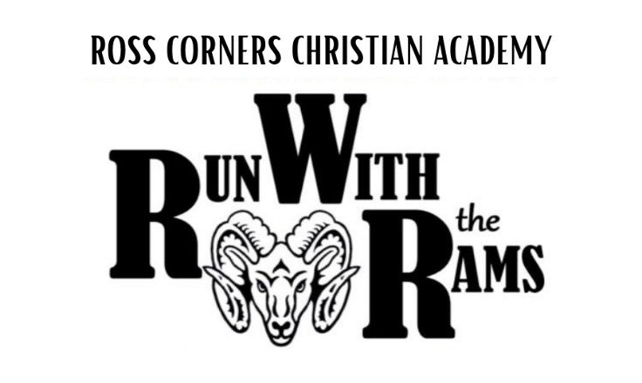
Together we can make a difference.
Will you help our school ~
Ross Corners Christian Academy?
“Whosoever wants to be great among you must be the servant of all”

April 2026

Dear ________________________,

It is time once again for RCCA’s annual “Run with the Rams” fundraising event. Over the past several years our school has been able to assist some of our parents with financial needs, providing them with tuition assistance for their children to attend our school.

This year’s event will be held on Thursday, May 21, 2026. Our school’s goal is for each student to seek donations from family and friends to sponsor them as they run/walk laps around our soccer field for 30 minutes. Thanks to our Corporate Sponsors, 100% of every dollar raised will go toward our 2026-2027 scholarship fund.

Our family has been challenged to raise $600. Would you consider sponsoring in this endeavor? There will be a grand prize for the family who raises the most donations. Donations must be received prior to May 21st in order to qualify toward this. Many thanks for your consideration and help. Please keep in mind that all gifts are tax deductible.

Donations may be made online or by mail. A return envelope is enclosed for you.

To donate online, visit our website: www.rccarams.org. Click on “RWR 2026” under the Events tab and then click on “Sponsor a Student or Staff Member Here”. This will bring you to our RWR 2026 Race Website. Click on the student or staff member you would like to support.

To donate by mail, Cut and return portion below with your donation.
-------------------------------------------------------------------------------------------------------------------------------

YES, I would like to sponsor _______________________________________ in RCCA’s “Run With The Rams” Fundraising Event. Family Name

Name _____________________________________________________________

Street Address ______________________________________________________

City ______________________________________State_______ Zip__________

Phone Number(s) ___________________________________________

E-mail Address____________________________________@____________________________

Donation Amount $______________________

Please make checks payable to Ross Corners Christian Academy
Thank you for your support!
Cash or Check Donations will receive a tax deductible statement by mail.
RCCA is a tax exempt charity under IRS 501-c-3

